ATLS 5519 IOS Development Project 2 plan – Short Poem Helper Tool
Luis Hierro

This App is designed to help people make short verses quickly. It is not really aimed at those who are truly passionate about poetry; it is more of a casual app to start up conversations.

Application flow:

The app will be made using storyboards and there will be three main views:

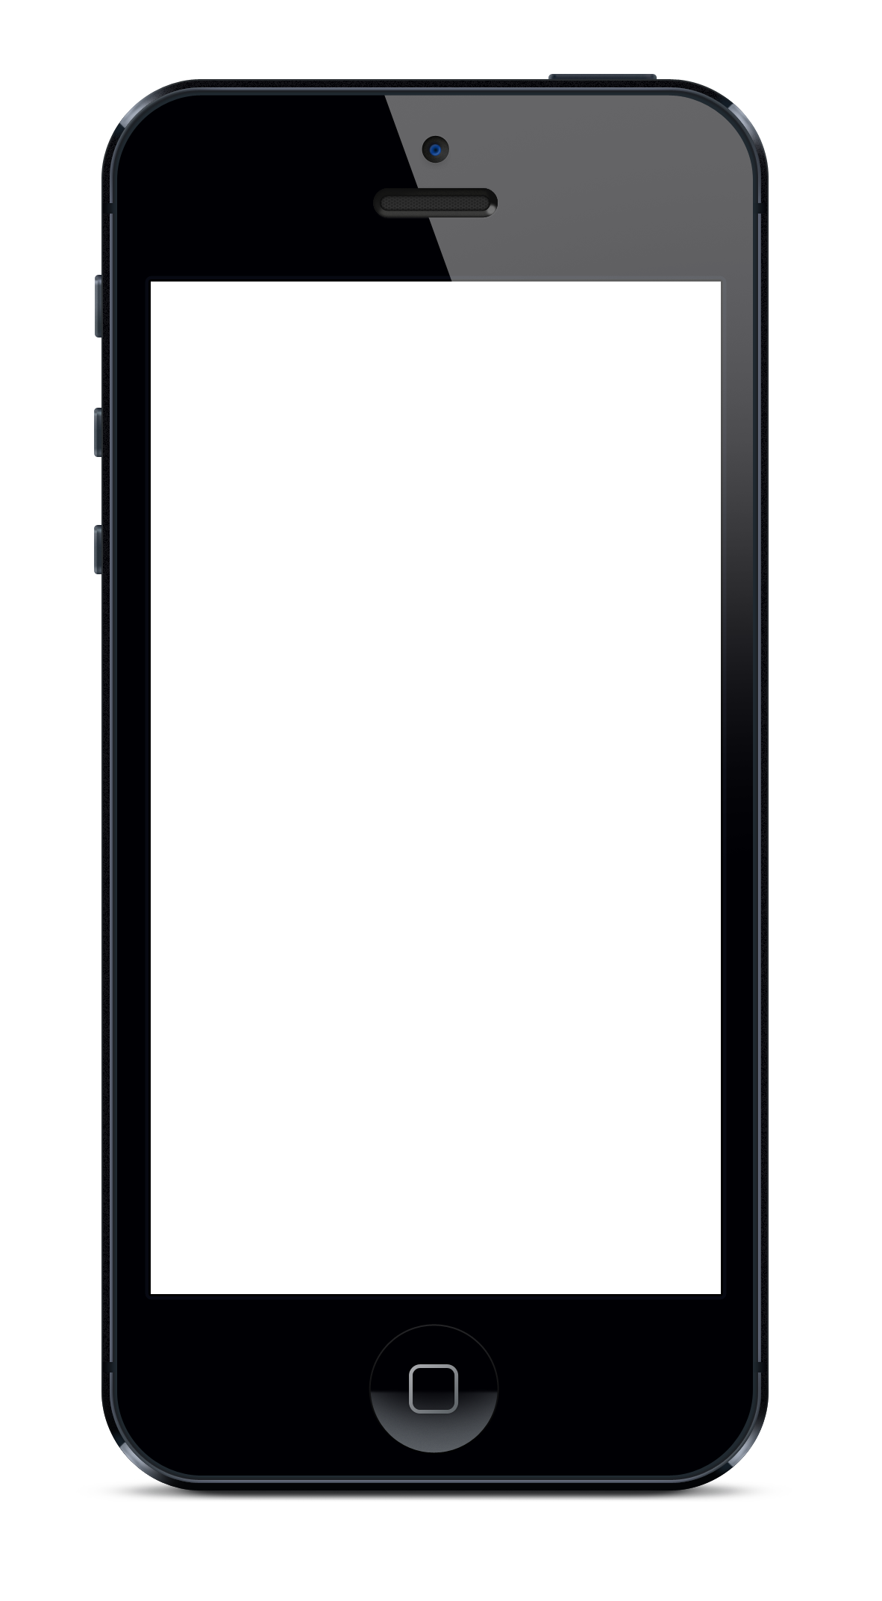

Start
Design
TableView
Search

1.The app starts at the main screen:
2.user presses start button which transfer user to the design screen.
3.User starts typing verse
4.User can double tap on given word in text field which copies it to label at top of design screen (copyWordFromTextField method)
5.When user presses search button, the searchButton method will make app go to table view showing the words that rhyme with the search entry.
7.User selects word then hits done
8. User is taken back to design screen and selected word is copied to the end of same line user was typing last

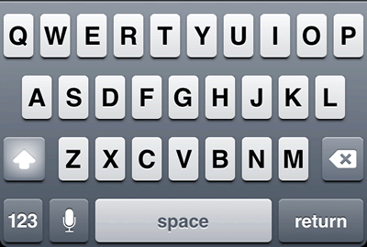
Design Screen:
Verse 1
Verse 2
Verse 3
Verse 4
Selected Word
Search

Testing and challenges:

There will be heavy testing specially in the searchButton method. The method will have to create a tableview with different data every time it is called. It will have to handle misspellings by user and server time out.
Unfortunately there is no .plist file available with rhymes I’m attempting to use a web service that returns the rhymes in an xml format. The method will have to send the query and wait for response. Once response is in it will populate the table view.

Here is an example:
Request:

http://www.stands4.com/services/v2/rhymes.php?uid=3059&tokenid=atSvBverv00epQtY&term=rhyme

(try pasting on the address bar of a browser the word after the equals sign is the user input)

Response:

<result><term>rhyme</term><rhymes>rhyme, rime, seim, sime, slime, syme, thyme, time, part-time, sublime, anticrime, prime, mime, lyme, beim, chime, climb, clime, dime, grime, haim, heim, hime, i'm, lime, kime, nime, ryme, fine, crime, shine, thime, denime, seem beam, partner in crime, bedtime, daytime, downtime, halftime</rhymes></result>

I’m Looking into the NSXMLParser class for this.

The copyWordFromTextField method might prove challenging as well. Method will have to copy words from a text field so that they can be passed to the searchButton method. Words would have to be selected by a simple gesture like a tap or double tap.

